
TaskTick User Manual
Version 1.0
Release Date
May 2026


Table of Contents
1. Application Overview 3
1.1 Product Introduction 3
1.2 Main Features 3
1.3 Technical Information 4
2. Getting Started 5
2.1 First Launch 5
2.2 Creating a Task 7
3. Using the Application 10
3.1 User Login and Registration 10
3.1.1 Creating an Account 10
3.1.2 Logging in 15
3.1.3 Incorrect Password Notification 17
3.1.4 Logging out 19
3.2 Task Management 20
3.2.1 Adding Tasks 20
3.2.2 Viewing Tasks 20
3.2.3 Deleting Tasks 21
3.3 User Profile 23
3.3.1 Editing Profile Information 23
3.3.2 Friend Management 24
3.4 Offline Mode 25
3.4.1 Using Offline Mode 25
4. Frequently Asked Questions 27
4.1 Data Management 27
4.2 Account Management 27
4.3 Application Features 27
5. Technical Information 28
5.1 System Requirements 28
5.2 Installation (One-Time Setup) 28
5.3 Development Framework 29
5.4 Supported Platforms 29
5.5 Version Information 29
5.6 Known Limitations 29
6. Appendix 30
6.1 Glossary 30
6.2 Change Log 30

Application Overview

Product Introduction
TaskTick is a task management application designed to help users organize daily activities efficiently. The application includes user account management, task creation and deletion, calendar-based date selection, profile management, friend management, and offline functionality.
When users operate in login mode, all data is stored persistently and remains available after the application is closed and reopened.

Main Features
User Account System
- User registration
- User login
- User logout
- Persistent data storage

Task Management
- Add tasks
- Select task dates
- Delete tasks

Profile Management
- Edit personal information
- Manage friends

Offline Mode
- Use the application without logging in
- Data is stored temporarily and not saved permanently

Technical Information
TaskTick is developed using React Native and Expo and supports iOS, Android and Web browsers.
The application uses AsyncStorage and SQLite for persistent local data storage.

Getting Started

First Launch
When TaskTick is opened for the first time, users will be presented with the Welcome Screen.
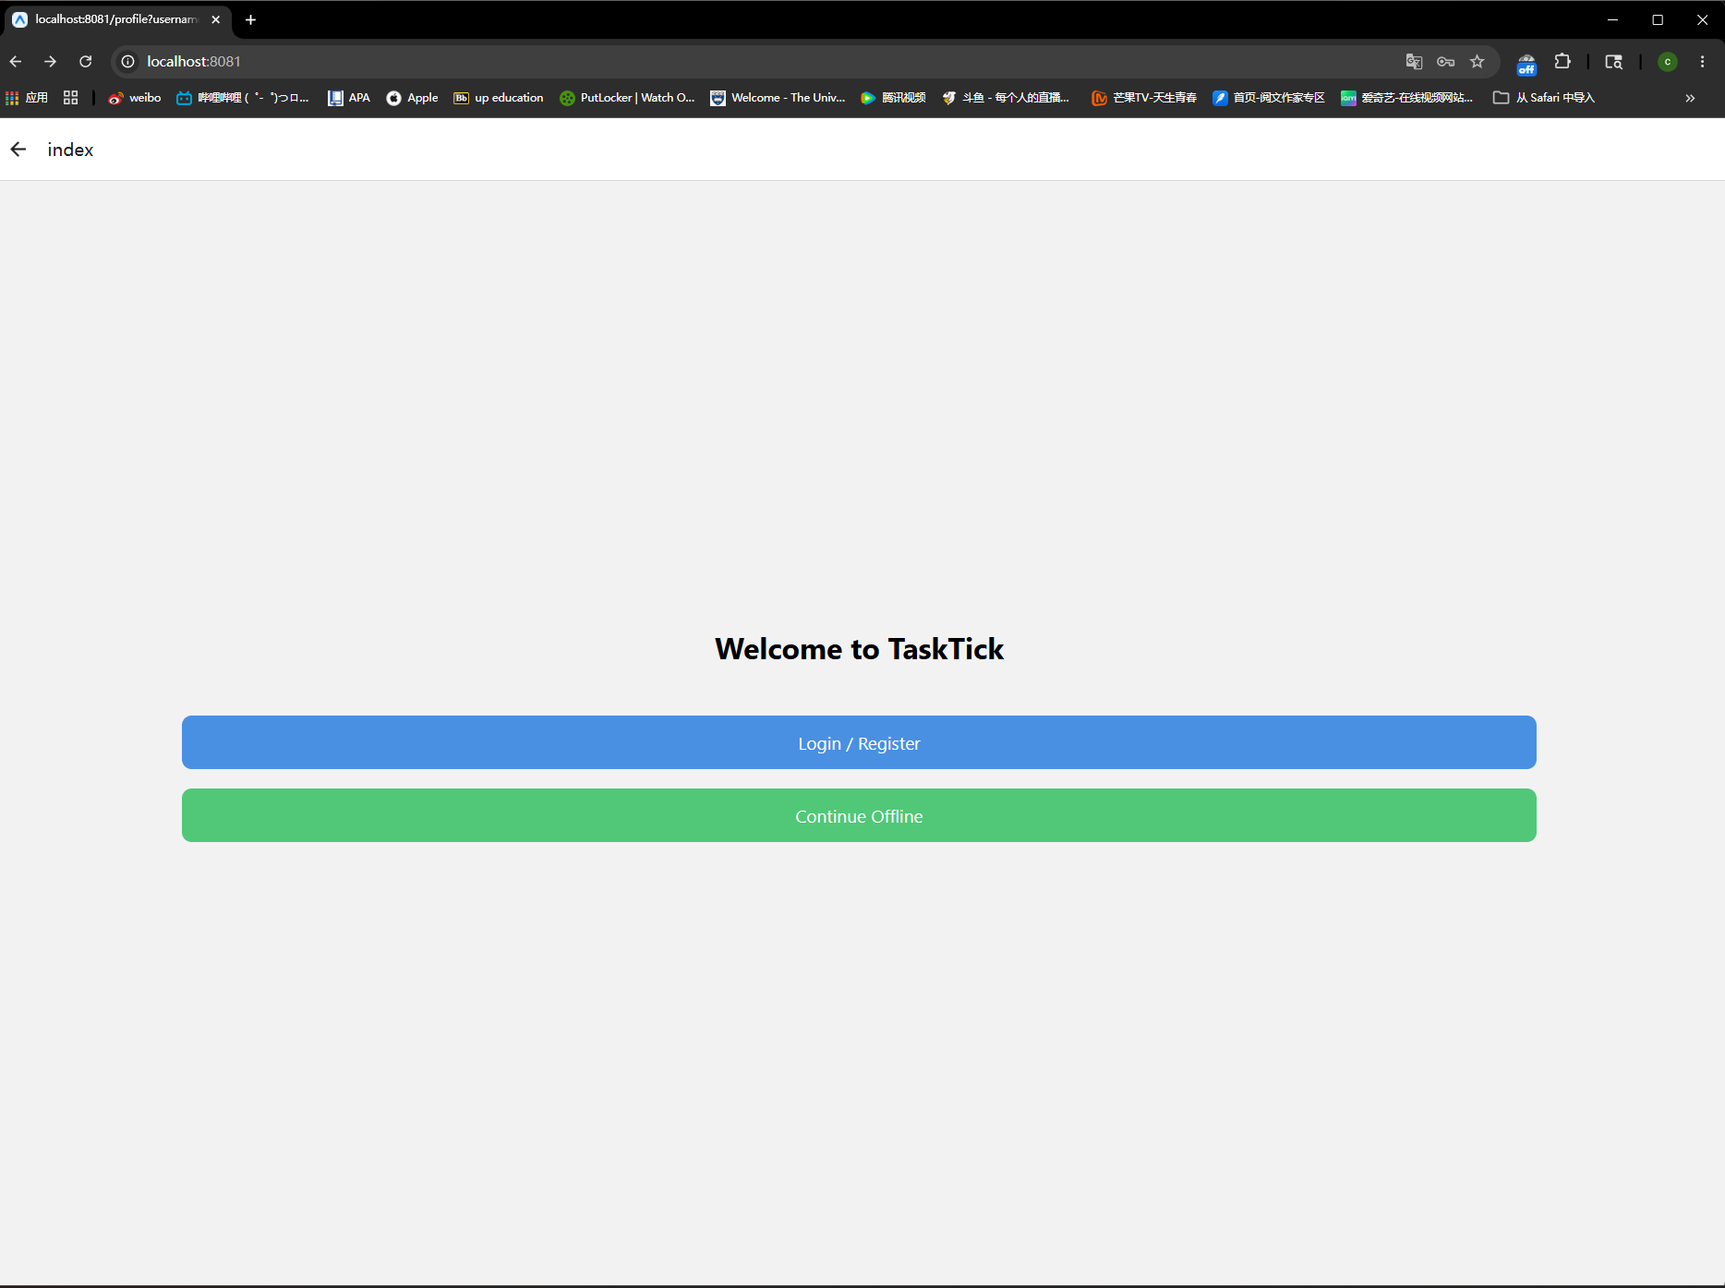
Web Page (Welcome to TaskTick)

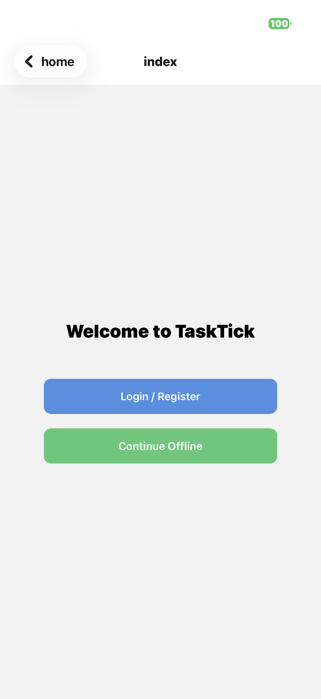IOS (Welcome to TaskTick)
Users may choose one of the following options:
Option 1: Login / Register
- Click Login / Register
- Enter your username and password if you already have an account
- Select Create New Account if you do not have an account
- After successful login, the Task Management page will open
Option 2: Continue Offline
- Click Continue Offline
- Access Offline Task Mode immediately
- Data created in this mode will not be permanently saved

Creating a Task
1. Enter task details into the task input field
2. Select a Task Date using the calendar (optional)
3. Click:
- Add Task (Login Mode)
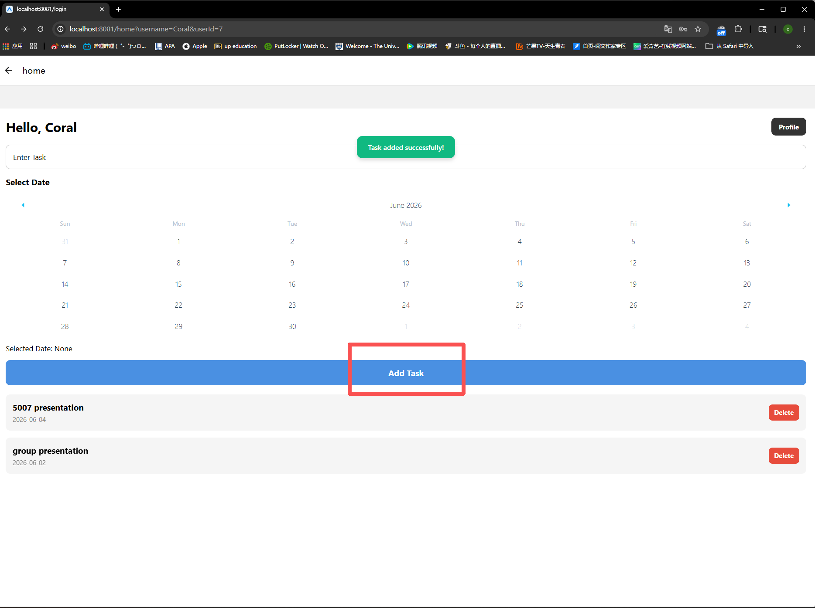
Web Login Page (Add Task)
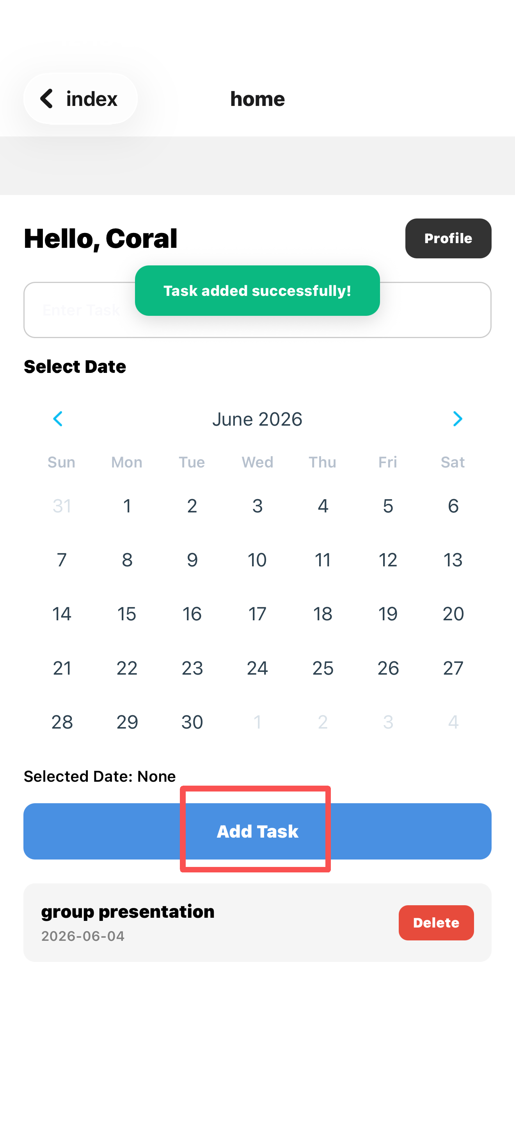
IOS Login (Add Task)
- Add Offline Task (Offline Mode)
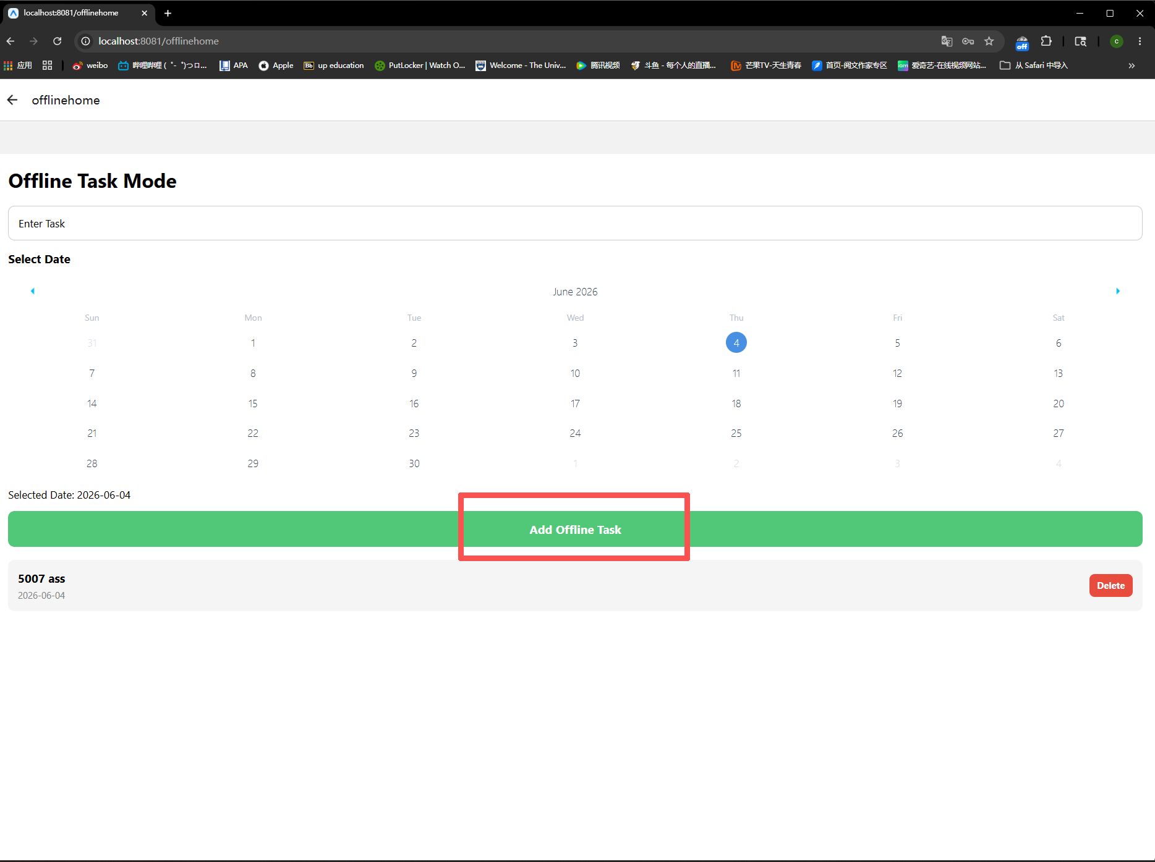
Web Offline page (Add task)
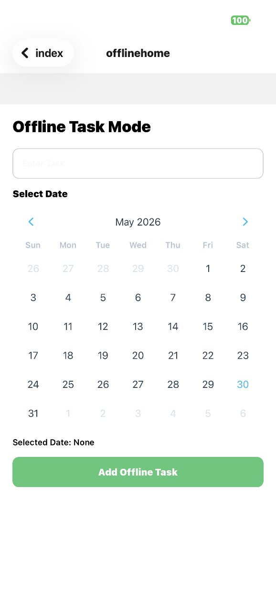
IOS Offline (Add Task)
4. The Task will Appear in the Task List.

Using the Application

User Login and Registration

Creating an Account
- Click Login / Register
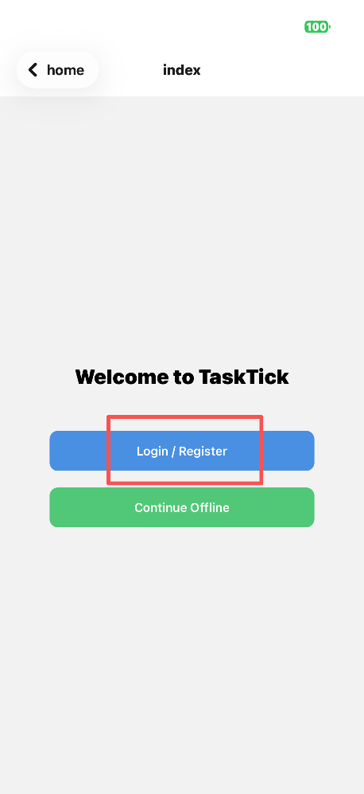
IOS (Main Page)

Web (Main page)
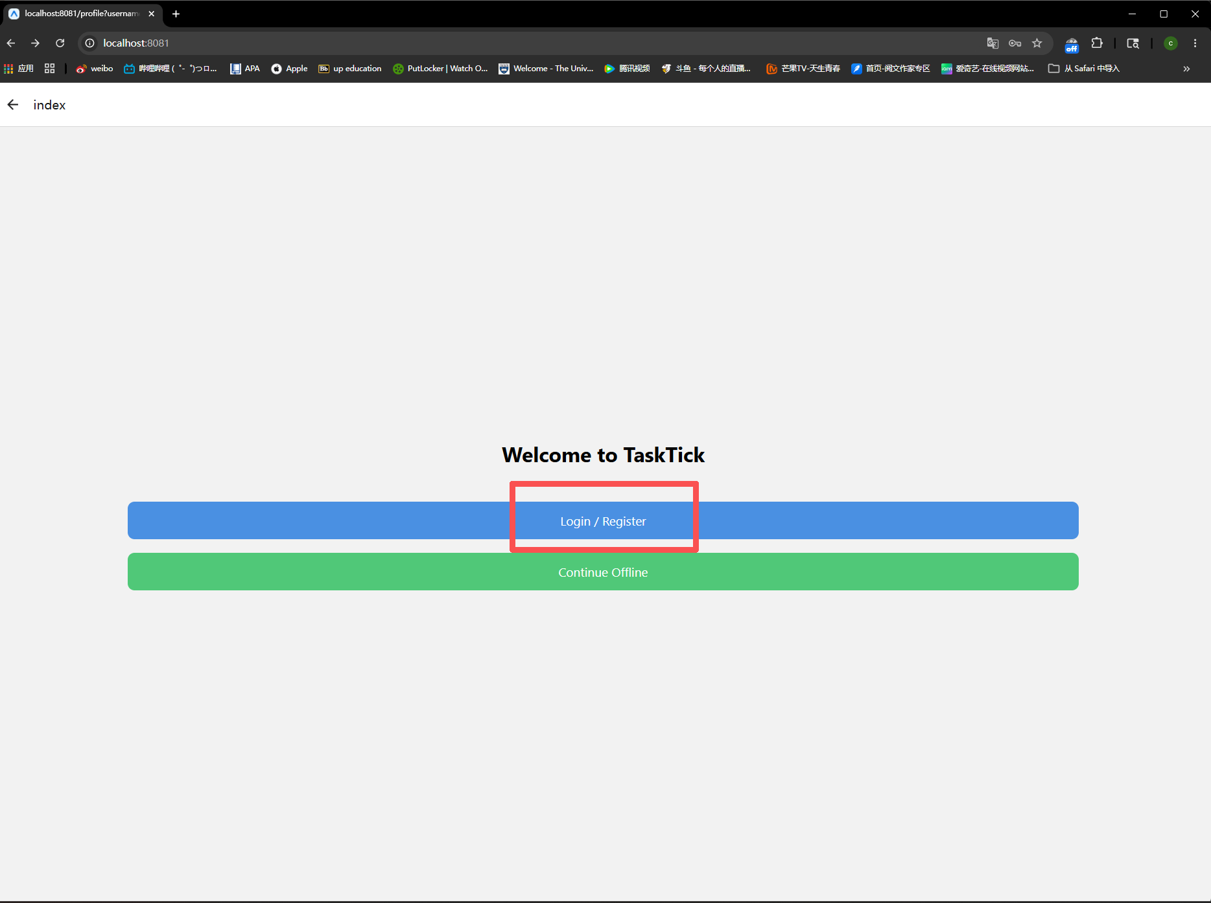
- Select Create New Account
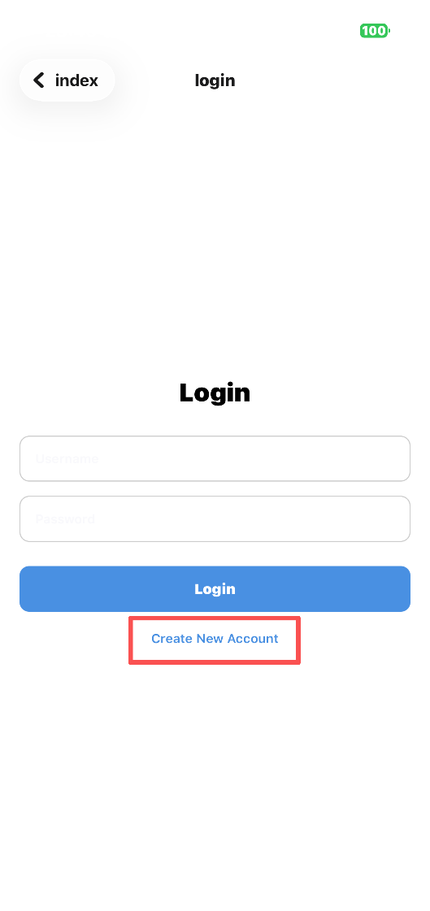
IOS (Login page)

Web Page (Login page)
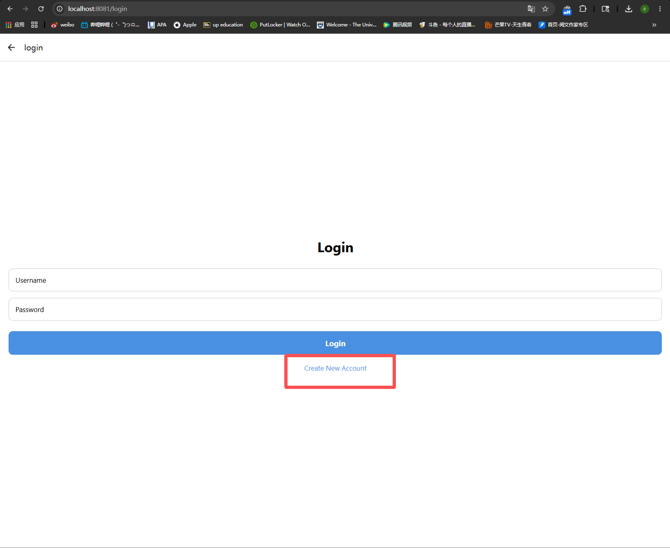
- Enter: Username, Password, Confirm Password
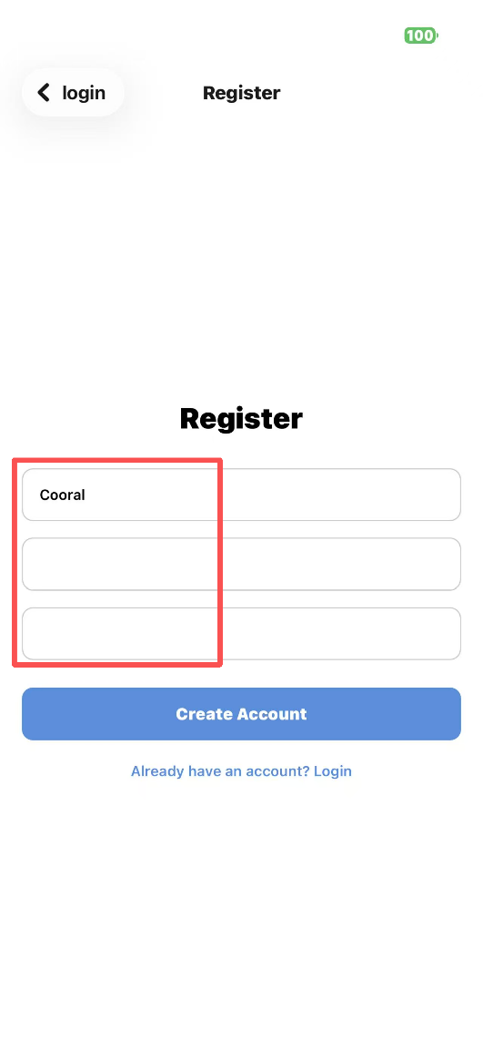
IOS (Register page)

Web (Register page)
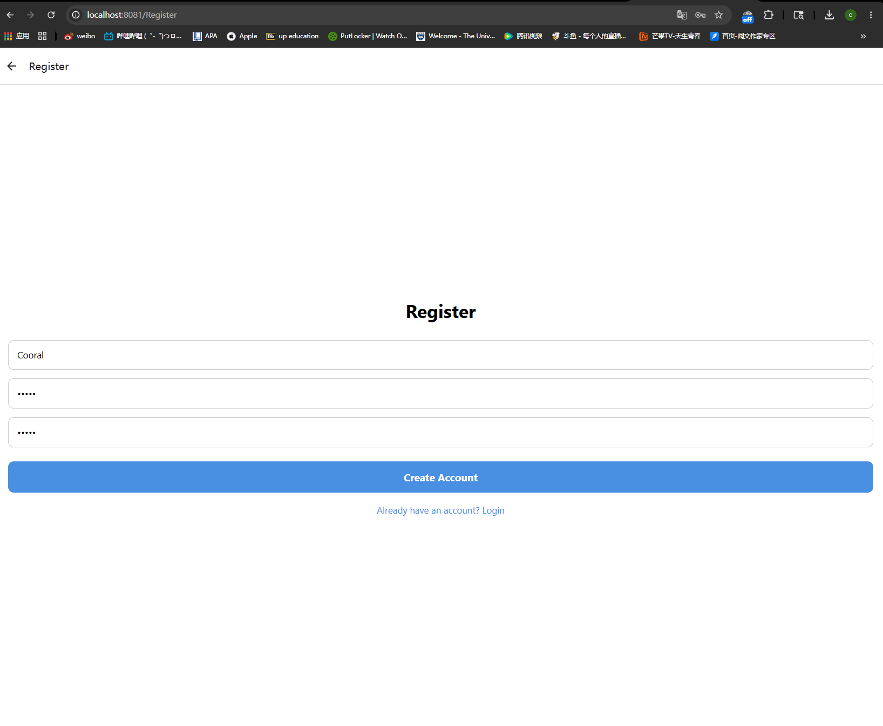
- Click Create Account
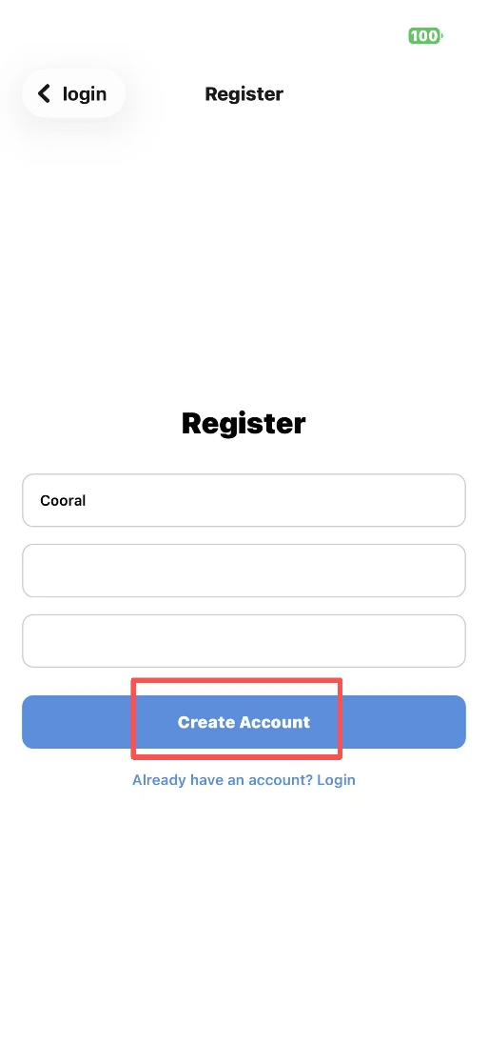
IOS (Register page)

Web (Register page)
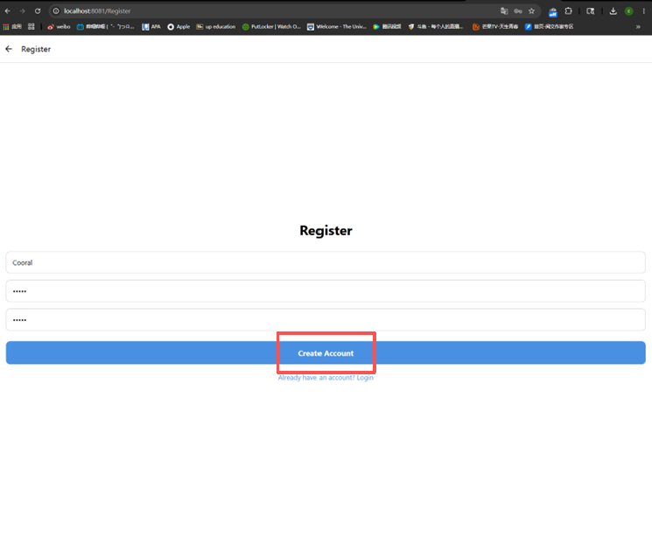
! ! Requirements
- Usernames must be unique
- Passwords must contain at least 4 characters
- Password and confirmation password must match

Logging in
- Enter your username and password
- Click Login
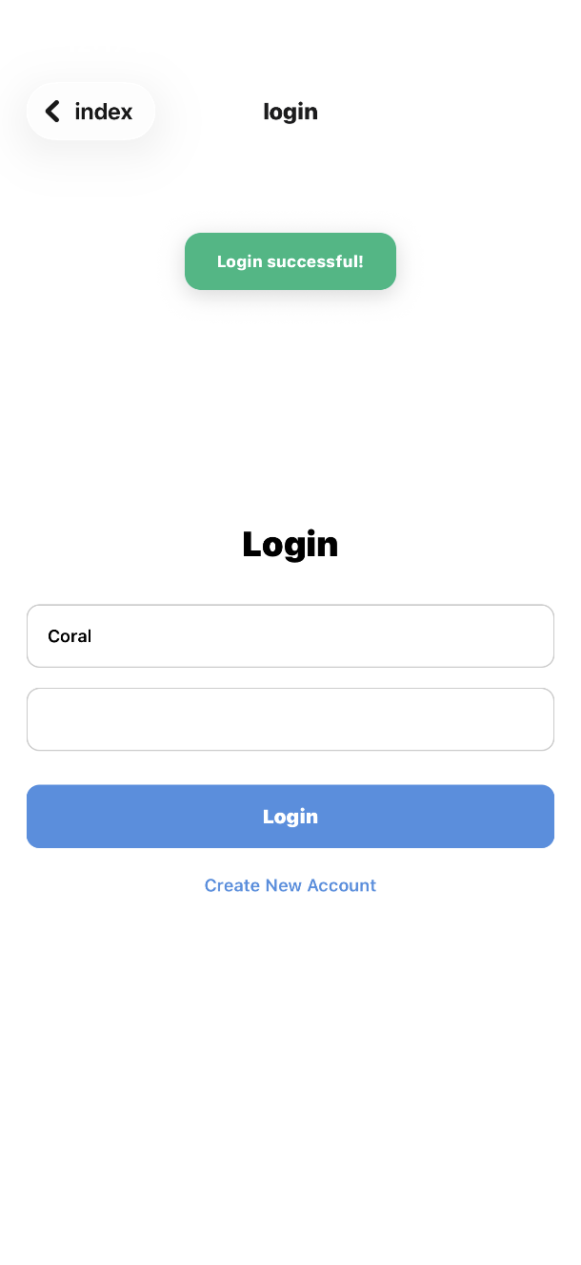
IOS (Login page)
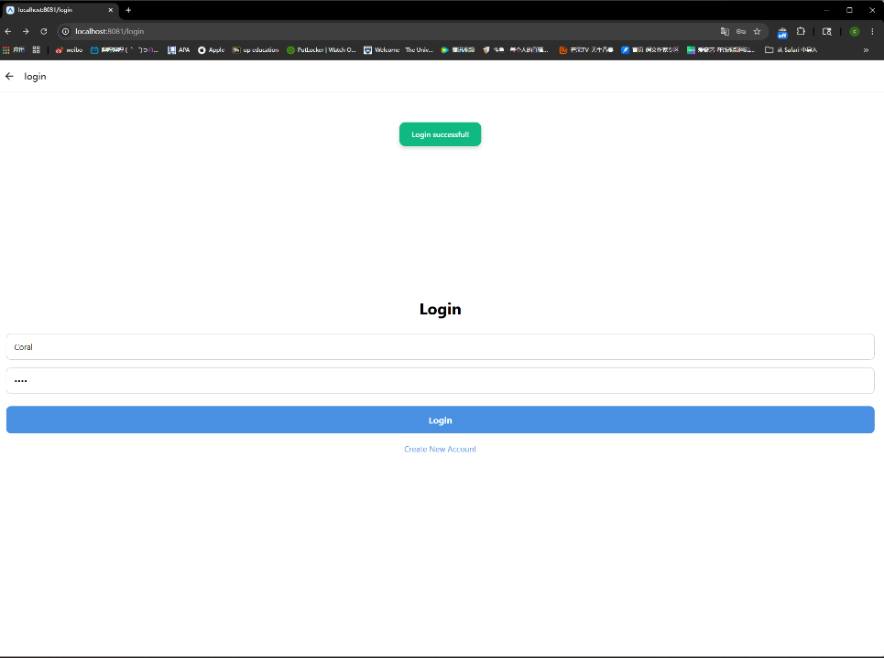
Web (Login Page)
- The application will automatically navigate to the Task Management page after successful authentication
! ! Notes
- Users must register before logging in
- Username and password must match registered account information

Incorrect Password Notification
If an incorrect username or password is entered, the application will display an error message informing the user that the login attempt has failed.
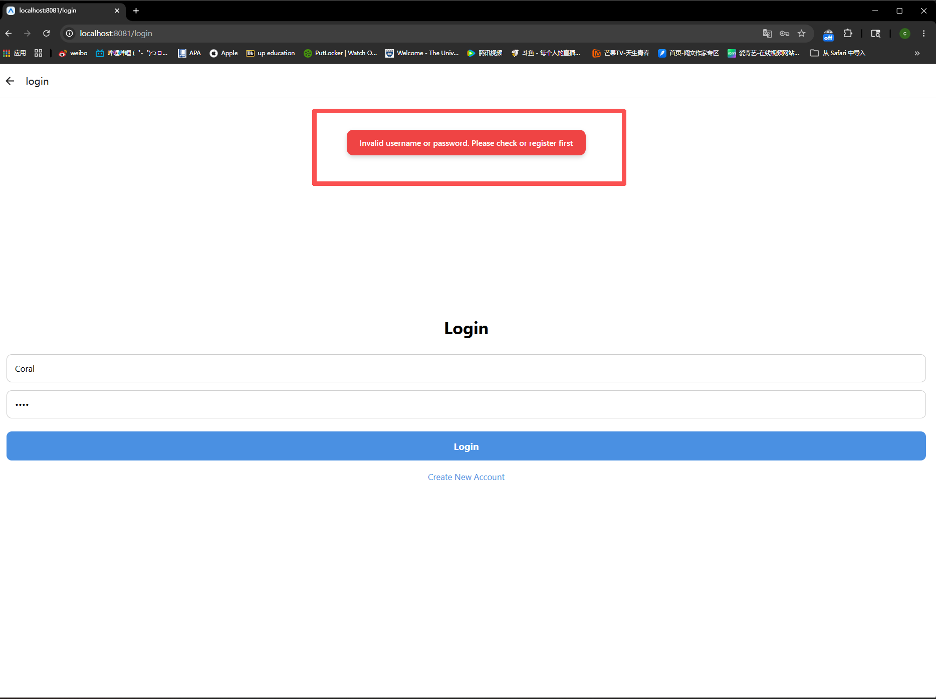
Web (Incorrect Password Notification)
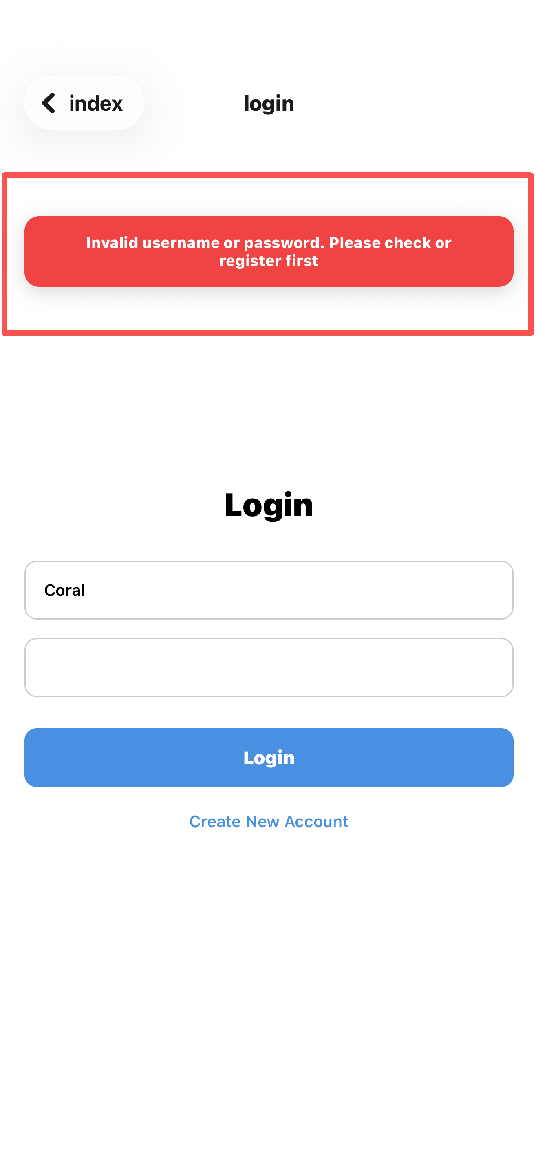
IOS (Incorrect Password Notification)

Logging out
- Open the Profile page
- Click Logout
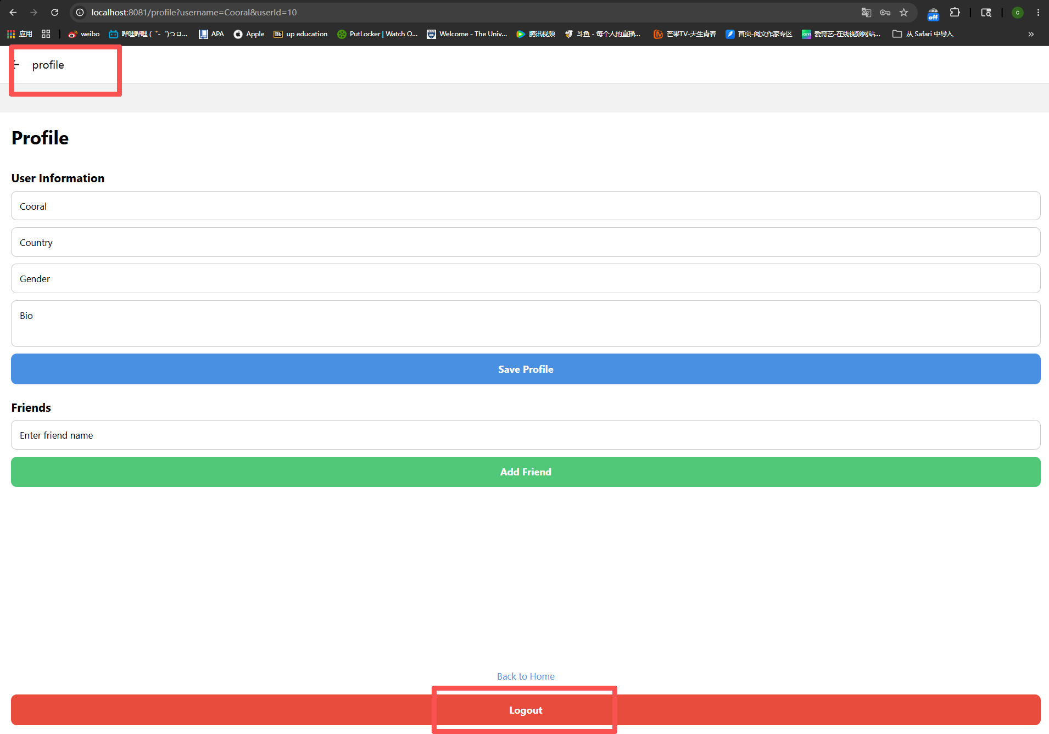
Web (Profile page)
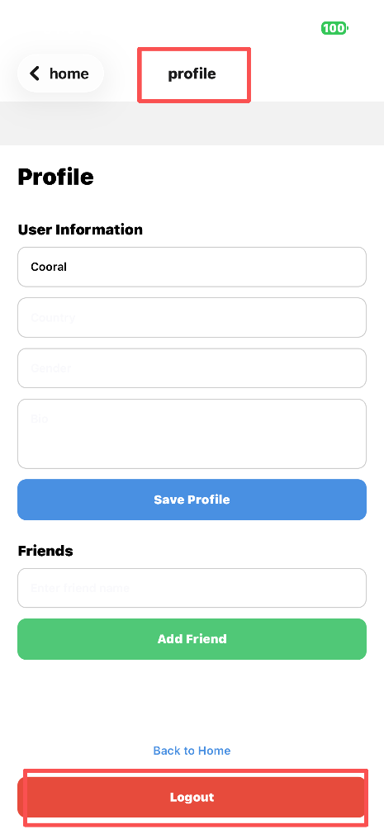

IOS (Profile page)

- The application returns to the Welcome Screen

Task Management

Adding Tasks
- Enter a Task Title
- Select a date using the calendar(optional)
- Click Add Task or Add Offline Task
- The task will be added to the task list

Viewing Tasks
- Tasks are displayed in chronological order of creation
- Each task card shows:
- Task title
- Selected date
- Selected dates are highlighted on the calendar
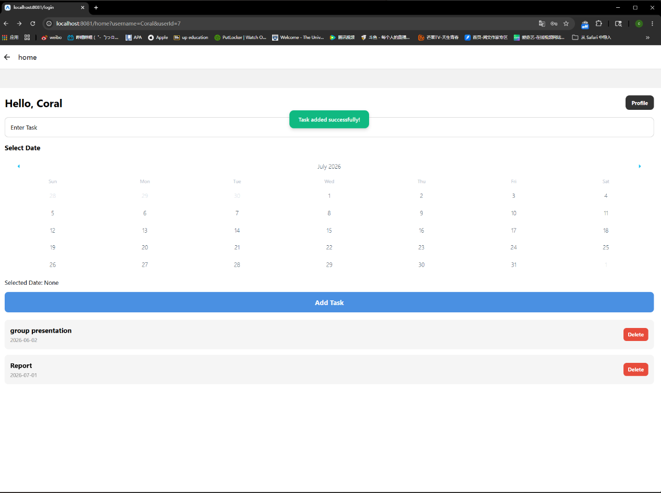
Web (Task management page)
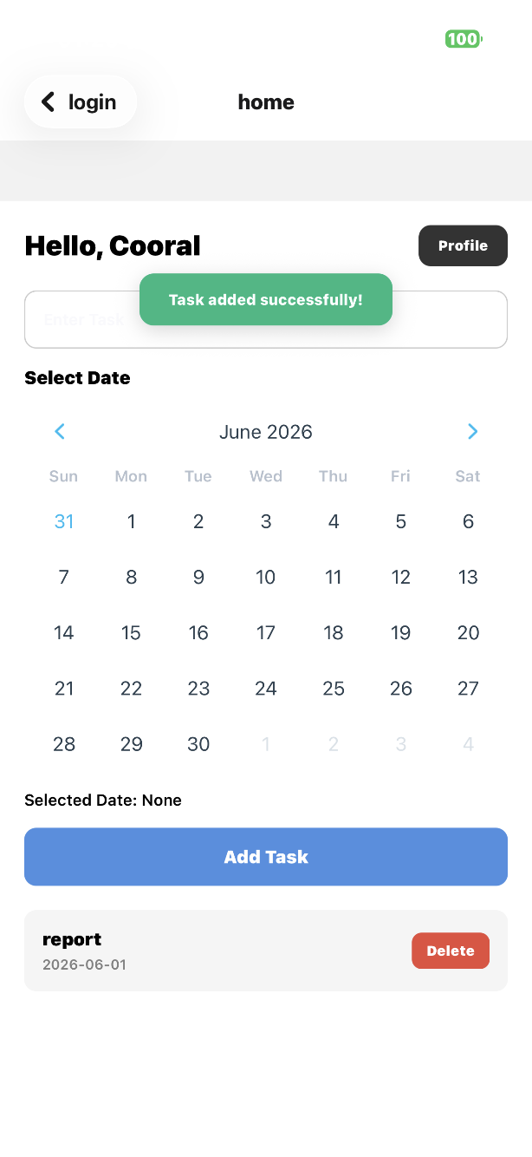
IOS (Task Management)

Deleting Tasks
- Locate the task in the task list
- Click the Delete button
- The task will be removed permanently
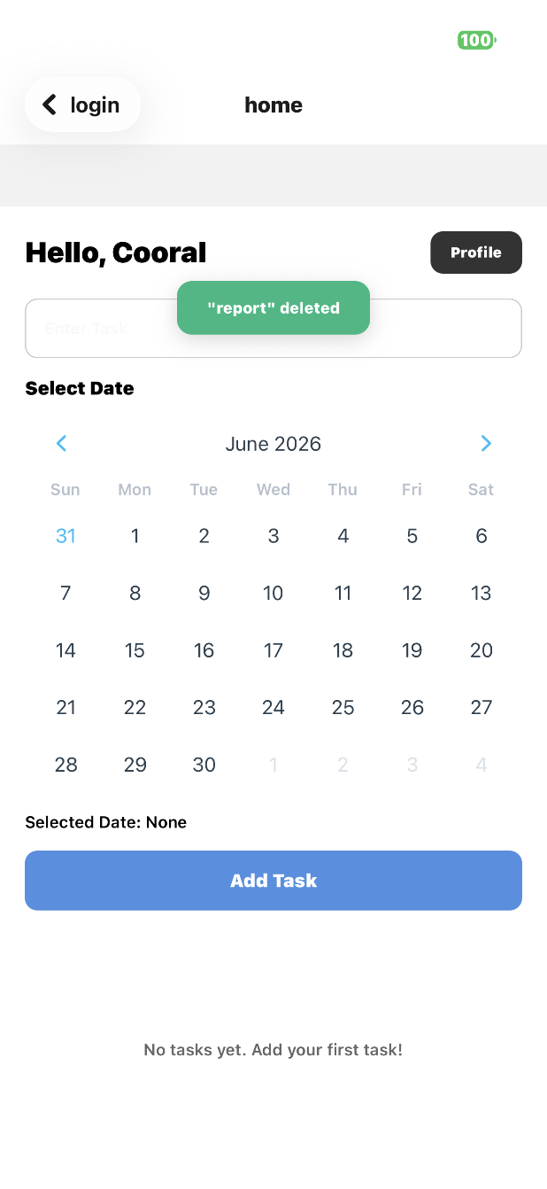IOS (Task Page)
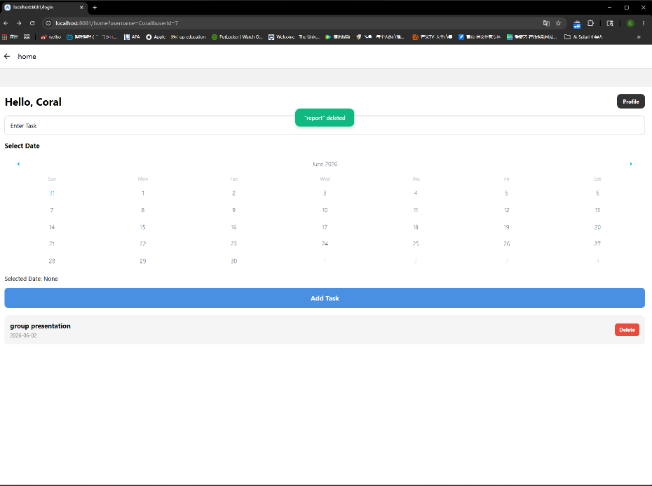Web (Task page)

User Profile

Editing Profile Information
- Click the Profile button in the upper-right corner
- Edit the following information:
- Display Name
- Country
- Gender
- Biographical
- Click Save Profile
- A success message will be displayed
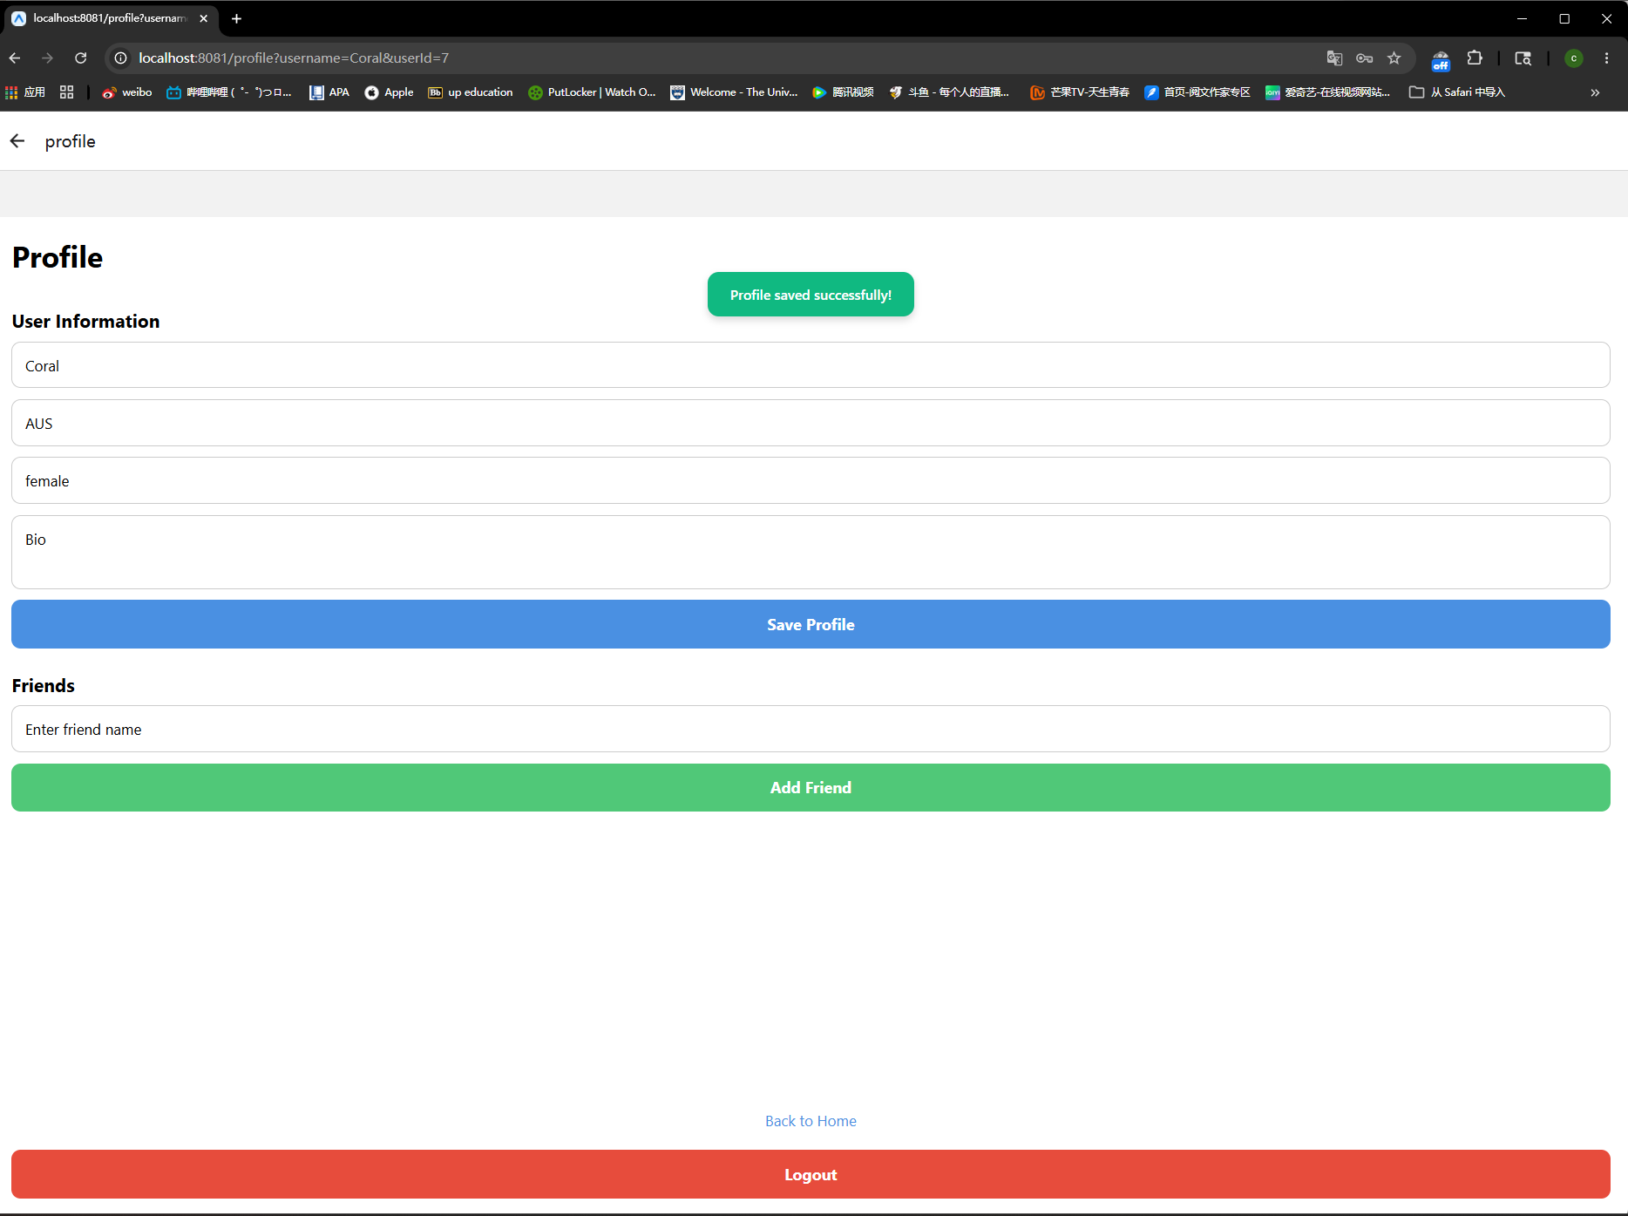
Web (Profile page)
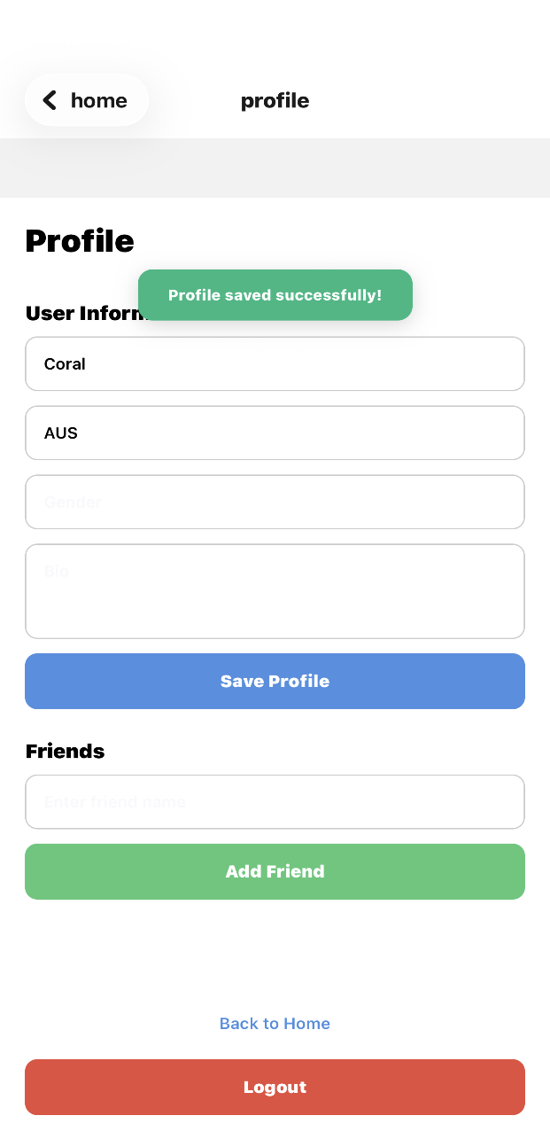
IOS (Profile page)

Friend Management
- Navigate to the Friends section
- Enter a friend’s name
- Click Add Friend
- To remove a friend, click Remove next to their name.

Offline Mode

Using Offline Mode
- Click Continue Offline
- Enter Offline Task Mode
Available features include:
- Add Tasks
- Select Dates
- Delete Tasks
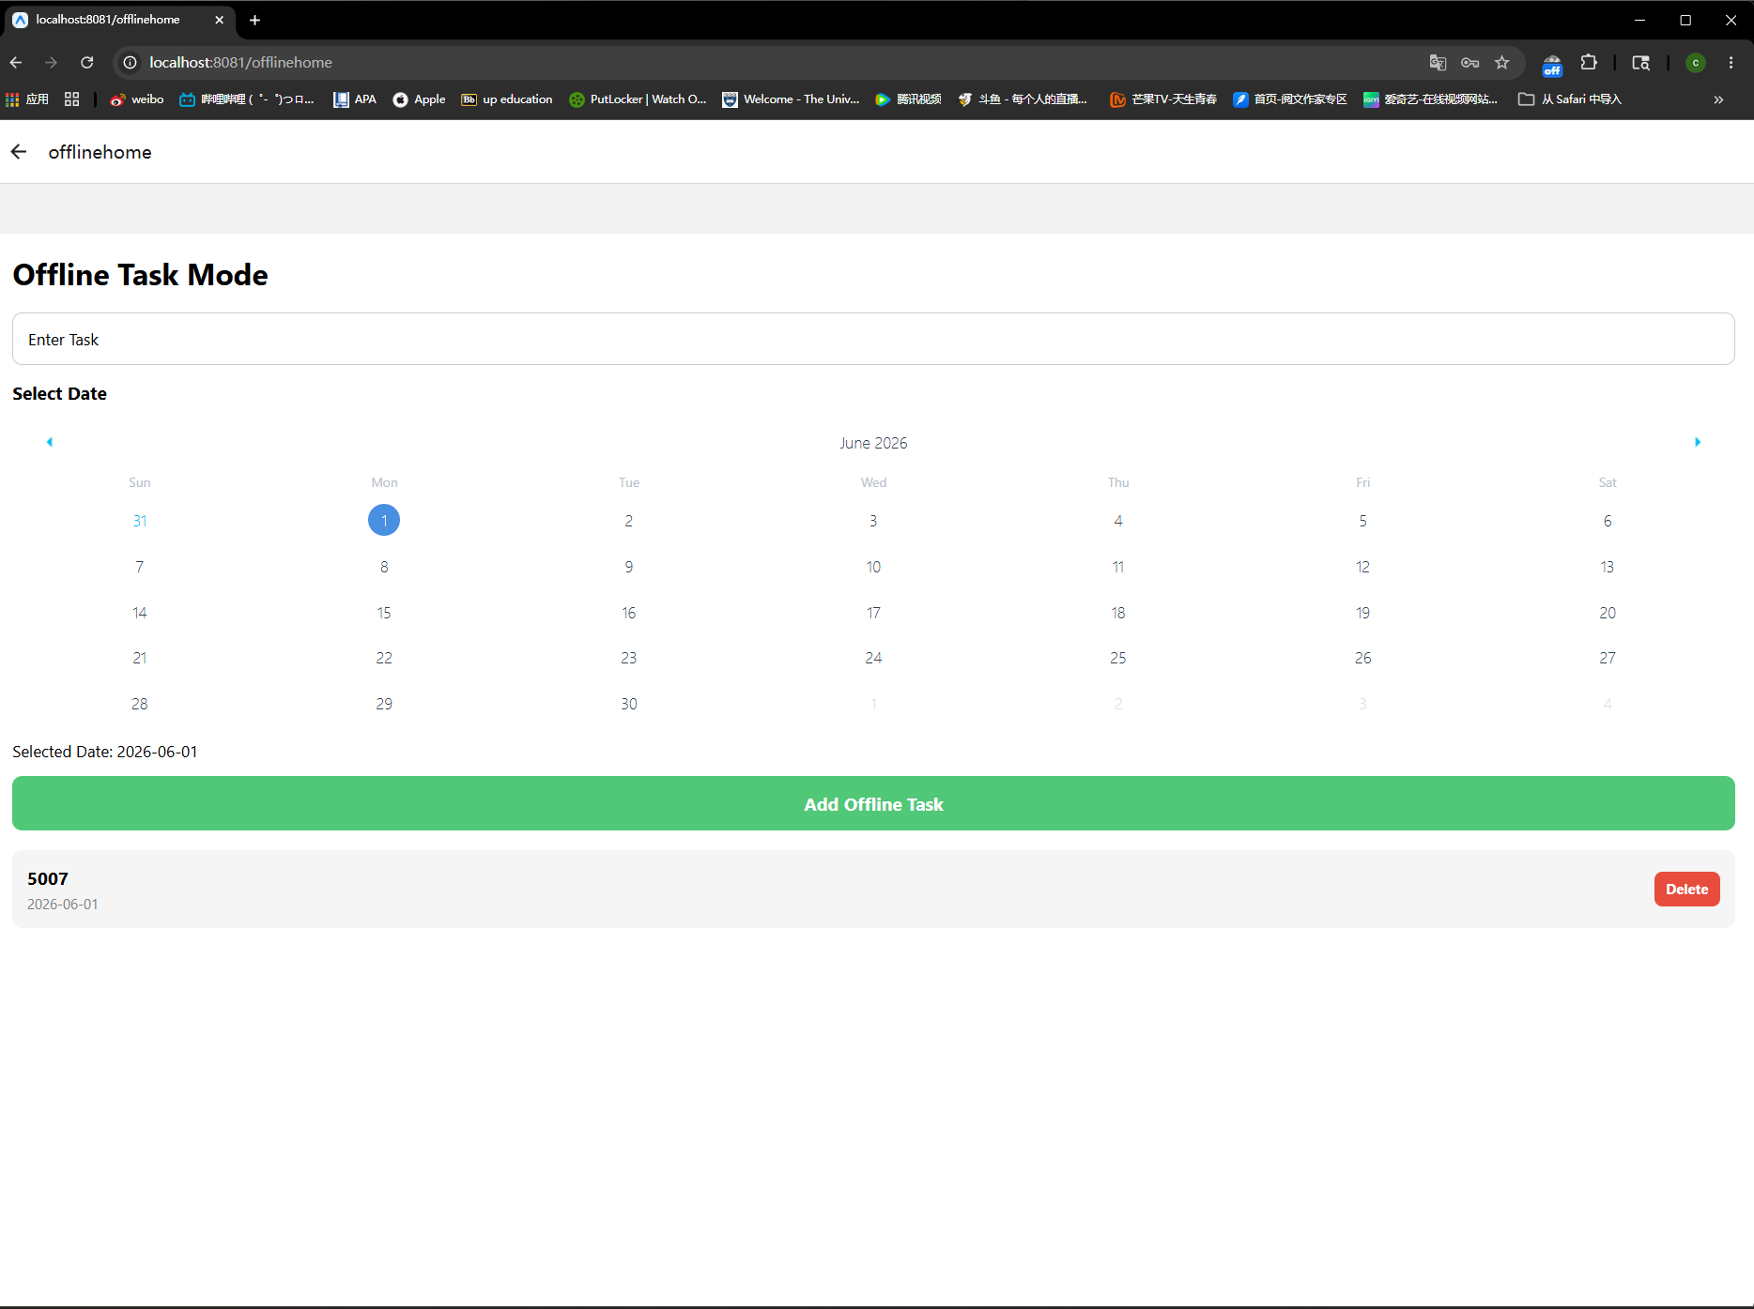
Web (Offline task page)
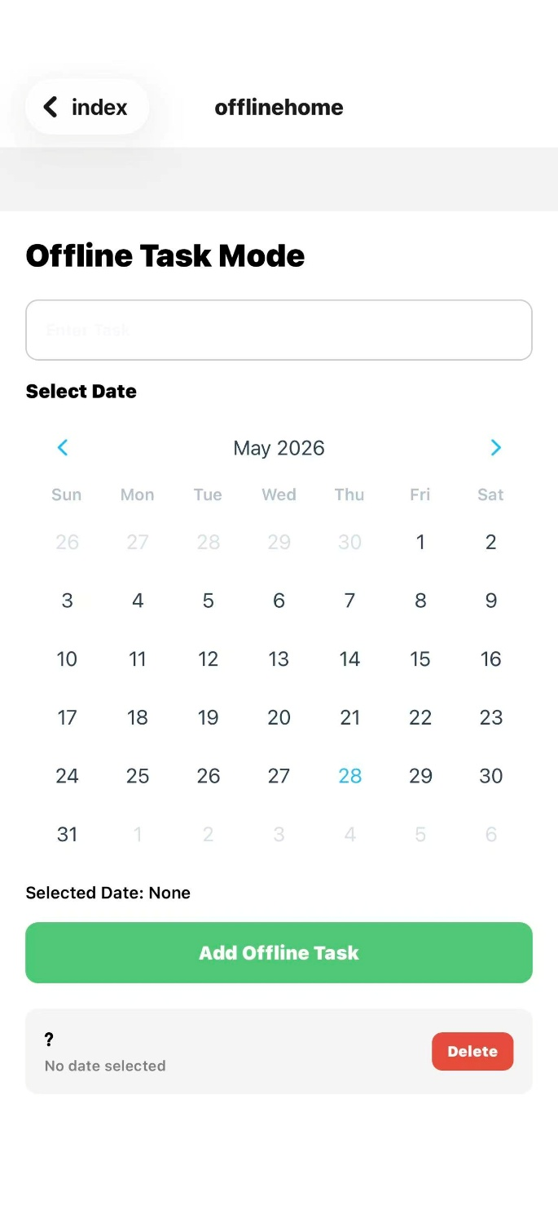
IOS (Offline page)
! ! Important Notes
- Offline data is stored only in memory
- Data is lost when the application closes
- Offline Mode data is separate from Login Mode data

Frequently Asked Questions

Data Management
Q: Will my task data be saved?
A: Yes. In Login Mode, all tasks, profile information, and friends are stored persistently. In Offline Mode, data is only stored temporarily and will be lost after closing the application.
Q: Is data synchronized between Offline Mode and Login Mode?
A: No. The two modes are completely independent.
Q: How can I ensure my data is saved?
A: Use Login Mode. Data is automatically stored locally using persistent storage.

Account Management
Q: Do I need to register an account?
A: Yes. Registration is required before using Login Mode.
Q: Can I recover my password?
A: No. Password recovery is not supported in Version 1.0.0.
Q: Is profile information saved?
A: Yes. Profile information is stored persistently and remains available after future logins.
Q: Can multiple accounts be used on the same device?
A: Yes. However, only one account can be logged in at a time.

Application Features
Q: Does TaskTick support reminders?
A: No. Reminder functionality is not available in Version 1.0.0.
Q: Can I edit an existing task?
A: No. Users must delete the existing task and create a new one.
Q: Which devices are supported?

Technical Information

System Requirements
Requirement | Minimum
Operating System | Win 10/11, macOS 12+, Android 6.0+, iOS 13.0+
Storage Space | 100 MB free storage
Memory (RAM) | 2 GB minimum
Internet Connection | Required for account registration and login features
Browser (Web Version) | Google Chrome, Mozilla Firefox, Safari, Microsoft Edge
Mobile Device | Android or iOS smartphone/tablet

Installation (One-Time Setup)
Mobile Version (Android / iOS)
- Download and install the TaskTick application.
- Launch the application from your device.
- Grant any required permissions if prompted.
- The Welcome Screen will appear.
Web Version
- Open a modern web browser.
- Navigate to the TaskTick web application URL.
- Wait for the application to load.
- The Welcome Screen will appear.

Development Framework
TaskTick was developed using the following technologies:
Technology | Purpose
React Native | Cross-platform mobile development
Expo | Application development and deployment
Expo Router | Navigation and routing
TypeScript | Application programming language
AsyncStorage | Local persistent storage
SQLite | Structured local database storage
React Navigation | Screen navigation and routing
Firebase Authentication | User account management

Supported Platforms
Platform | Status
Android | Supported
iOS | Supported
Web Browser | Supported
Windows Desktop | Experimental
macOS Desktop | Experimental

Version Information
Item | Information
Application | TaskTick
Current Version | 1.0.0
Release Date | May,2026
Development Framework | React Native + Expo
Programming Language | TypeScript
Supported Platforms | Android, iOS, Web
Authentication | Firebase Authentication
Database | SQLite + AsyncStorage
Development Environment | Visual Studio Code

Known Limitations
The Current Version of TaskTick includes the following Limitations:
- Task editing is not supported.
- Password recovery functionality is unavailable.
- Push Notifications have not yet been implemented
- Offline data is not synchronized with login accounts.
- User interface testing coverage remains limited
- Only one account can be logged in at a time.
- Task reminders are not currently available.

Appendix

Glossary
Login Mode: A mode requiring user authentication. All data is stored persistently.
Offline Mode: A mode that allows users to manage tasks without logging in. Data is stored only temporarily.
Persistent Storage: Data remains available after the application is closed and reopened.

Change Log
Version 1.0.0 (May 2026)
- Initial release
- User registration and login system
- Task creation and deletion
- Calendar date selection
- Profile editing
- Friend management
- Persistent local storage
- Offline mode support

Future Improvements
Future Improvements
TaskTick is currently a functional task management application; however, several enhancements are planned for future releases.
1. Task Editing Functionality
Currently, users can only add and delete tasks. Future versions will allow users to edit existing tasks without deleting and recreating them.
2. Push Notifications and Reminders
A reminder system will be implemented to notify users about upcoming tasks and deadlines. This feature will help users improve productivity and task completion rates.
3. Cloud Synchronization
Currently, data is stored locally on the device. Future versions may integrate cloud storage to synchronize tasks, profile information, and friend lists across multiple devices.
4. Enhanced User Authentication
Additional security features such as password recovery, email verification, and stronger password requirements may be added to improve account security.
5. Improved Friend Features
Future updates may include:
- Friend requests
- Shared task lists
- Collaborative task management
- Activity sharing
6. Performance Optimization
Additional testing and optimization will be conducted to improve application performance on older devices and under different network conditions.
7. User Interface Improvements
Based on user feedback and usability testing, the interface will be continuously refined to provide a more intuitive and user-friendly experience.
8. Cross-Platform Enhancements
Future versions may include dedicated desktop support for Windows and macOS, providing consistent experience across all platforms.

Thank you for using TaskTick!


